**SYSTEM AND OPERATIONS CONCEPT DOCUMENT**

This document provides a top-down view of the system from the user's perspective by describing

the behavior of the system in terms of operational methods and scenarios. Analysts should

provide the document to the development team by the end of the requirements definition phase.

**1. Introduction**

The purpose of this proposed project is to develop an IoT platform that will monitor the available parking spaces in a parking structure. In efforts to help reduce the amount of time taken to find available spaces, this system would be developed to help alleviate the amount of time it takes for people to find a space to park their vehicles by managing and displaying available spaces.

**2. System overview**

The overall system concept will be simple. Smart sensors that would detect vehicles will be able to communicate with the proposed IoT platform when spaces are occupied or unoccupied, and users would be able to view that information via a display or through their mobile devices. The IoT will have frequent recollection of data from the network of the smart parking sensors to allow for recent updates on their availability statuses. The platform would provide the information and display the output onto a monitor at the facility or to user mobile devices at the user’s request.

**Diagram of overall system concept:**

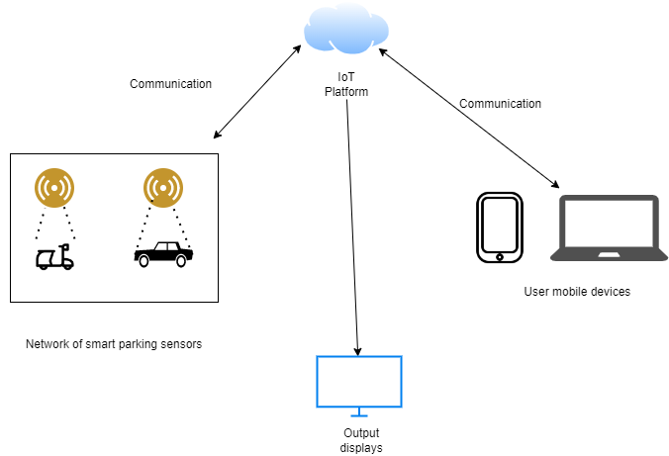

**4. Operational environment** -

The proposed IoT Platform will be designed on a based Ubuntu server. The platform is intended to be using LAMP stack and MySQL. The message broker that will be used is going to be MQTT (MQ Telemetry Transport). To provide constant updates about statuses of the parking sensors, communication between the platform and sensors should be relaying data transfers at the maximum speed required. The rule engine will be designed and serve as the platforms block for rules and conditions.

**Diagram of IoT Platform blocks:**

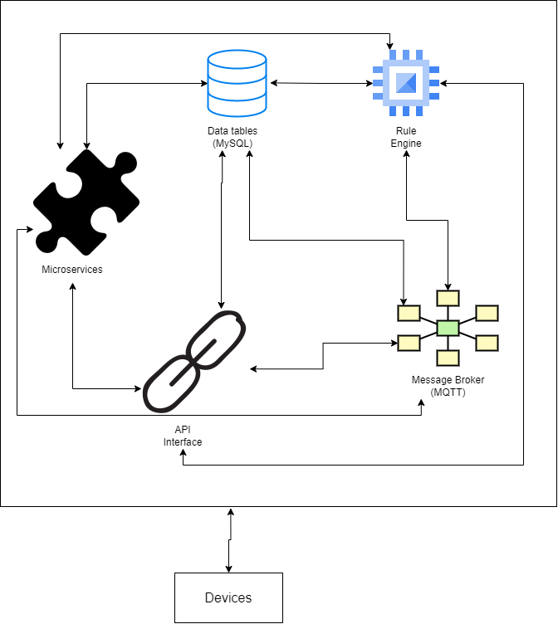

**5. Operational description of each major object**

**Parking sensors -** The parking sensors will be the physical devices that will detect vehicles occupying the parking spaces. Using ultrasonic wave technology, the sensors will emit ultrasonic waves and detect vehicles based upon reflections of the waves. Each individual sensor will communicate to the platform and provide frequent updates of availability,

**Output displays** – The output displays will be monitors that will display the information such as the total number of all parking spaces, the total number of available, the availability statuses of the parking spaces, and the locations of available spaces.

**Mobile devices –** The mobile devices will be the devices that users use to connect to the IoT Platform via a website application. The mobile devices will be allowed to request information about the total number of all parking spaces, the total number of available, the availability statuses of the parking spaces, and the locations of available spaces. The mobile devices will then be able to view said information in a similar way that the output display monitors will.

**Rule engine -** The Rule Engine will oversee reading messages that pass through the platform message buses and determine actions to take based upon the given set of rules and conditions.

**Message broker** – The message broker will be the backbone of the IoT platform allowing for communication between the different blocks in the platform and the external devices connected to the platform. The message broker will be designed as a MQTT broker.

**API Interface –** The API interface will be the center for hosting the user web application as well as the interface for the display monitors and smart parking sensors.

**Microservices –** The microservices will work in tandem with the API to micro device management services.

**Data tables –** The Data tables will be the database of information about the parking spaces. They will be constantly updated to show the correct information about each individual parking sensor such as their availability status, their functional conditions, their locations, their unique IDs, and recorded times of status change. The data that will be displayed contains the total number of all parking spaces, the total number of available, the availability statuses of the parking spaces, and the locations of available spaces.